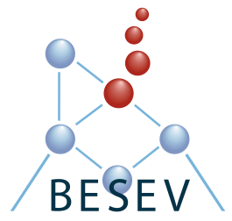
MOVE application
Deadline November 15th 2022

Belgian Society for Extracellular Vesicles
- Applicant information:

Name:

Laboratory:

University:

Address:

Tel.:

E-mail:

I am PhD student since (month/year):

I am Post-doc since (month/year):

Name of the applicant’s supervisor:

E-mail of the applicant’s supervisor:

- Current Research interest (max. 250 words)

- Host lab information:

Name of the host lab supervisor:

E-mail of the host lab supervisor:

Laboratory:

University:

Address:

- Project (max. 500 words)

I agree to the terms and conditions of the MOVE fellowship, including the production of a post-placement report in laymen terms which will be made public at the discretion of BESEV.

Signature of applicant:
Date:

Signature of applicant's supervisor:
Date:

Signature of host laboratory supervisor:
Date:

